Business Process: Western Area Power Administration

Contact
Business Process Owner | Billing Operations - Billing Solutions
Subject Matter Expert(s) | Amanda De La Cruz, Katherine Martinez, Shannon Whitley
Key Contact | Maya Duarte
Key Role | Customer Services Representative II  Senior Customer Services Representative
Date Created | 5/5/2026

Business Process Overview
This overview describes three distinct processes:
- Monthly Process:
This process begins when Billing receives the monthly office memorandum from Energy Settlements. Billing then updates the installation facts in SAP to reflect delivered energy by time-of-use period. Manual entries are reviewed by the Lead or, if a review is not immediately possible, the account is placed on bill block. The process ends once manual entries are audited and the customer billing is completed.
- Year-End Credit Optimization Process:
Each year, Pricing confirms delivered energy and sends the WAPA optimization credit report to Billing. Billing applies the post-document for the optimization credit, verifies the credit in bill history, and forwards the information to the Analyst for audit. The process concludes when the Strategic Account Advisor (SAA) has been notified of final approval.
- Annual Pricing Table Update Process:
When IT updates the annual pricing operands in SAP, Billing Performance notifies Billing Solutions. This process ends once all required SAP table updates are completed and validated.

Together, these processes govern how SMUD applies Western Area Power Administration (WAPA) energy credits to eligible customer accounts. WAPA customers receive federal power deliveries through SMUD, and SMUD compensates them with kWh credits that are established annually by Pricing and applied through Billing and associated support teams. The overall procedure encompasses both monthly billing updates and the annual pricing cycle, including installation fact updates, validation of new SAP pricing tables, and application of year-end optimization credits.

Business Process Assumptions, Prerequisites, Dependencies
(Assumptions pertaining to the business process)
People | - Assumptions:  - Pricing establishes the annual WAPA credit amounts each October for implementation on January 1 of the following year.  - Billing is responsible for monthly installation fact updates and year end processing for applicable WAPA customer accounts.  - IT is available to update the TOU credits in SAP for the next calendar year.  - Prerequisites:  - Billing must receive the office memorandum from Energy Settlements for monthly processing.  - Billing Performance must notify Billing Solutions when annual WAPA pricing updates are required.  - A Billing Solutions Lead must be available to review manual entries before invoicing, or the account must be bill blocked until review is completed.  - Dependencies:  - The process depends on Energy Settlements for monthly delivered energy data.  - The process depends on Pricing for annual credit values and the WAPA Credit Optimization report for Prison.  - The process depends on IT for SAP table updates.  - Analyst review is required prior to yearend credits posted to the account.
Process | - Assumptions:  - Monthly processing consists of updating Installation Fact Operands for WAPA energy credits based on the office memorandum from Energy Settlements.  - Annual processing includes validating SAP pricing updates and applying new credits effective January 1.  - Yearend optimization credits are processed only for Prison in Billing; County is handled by Energy Settlements and Accounting, and Nimbus is not subject to a true up event.  - Prerequisites:  - The office memorandum must be received before monthly installation facts are updated.  - Annual WAPA pricing must be available before the start of the new year.  - The WAPA Credit Optimization report must be received from Pricing before year end credits are posted.  - Dependencies:  - The process depends on upstream settlement, pricing, and budgeting activities to provide accurate source data.  - Monthly credit application depends on proper TOU allocation.  - Yearend processing depends on post document approval, audit review, and notification to the Strategic Account Advisor after posting.
Technology | - Assumptions:  - SAP is the system used to maintain Installation Facts, annual TOU credits, Bill Blocks, and post document adjustments.  - The credit values entered into SAP must align to the correct seasonal TOU periods and reflect the delivered energy provided by Settlements.  - Prerequisites:  - IT must update annual SAP pricing tables before January 1.  - Installation Facts must be configured with the correct seasonal valid dates.  - Bill Block functionality must be available if manual review cannot be completed before invoicing.  - Dependencies:  - The process depends on SAP billing transactions, Installation Fact maintenance, Bill Block controls, billing history, and post document functionality.  - The process depends on data transfers from Energy Settlements, Pricing, and IT into SAP.

Process Flowchart
Western Area Power Administration Process Mapping As Is.vsdx

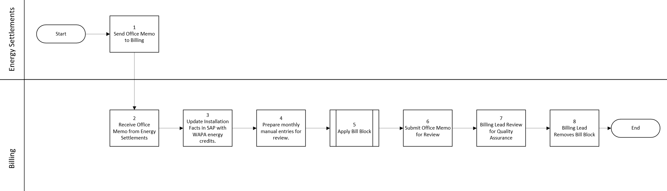

Task Description – Monthly Processing
Id | Task Description | Procedure
1 | Send Office Memo to Billing | Energy Settlements sends Billing the Office memorandum.
2 | Receive office memorandum from Energy Settlements | Billing receives the monthly office memorandum containing delivered Western energy by time-of-use period.
3 | Update Installation Facts in SAP with WAPA energy credits | Billing enters the delivered kWh amounts into the SAP Installation Facts for the applicable customer account.
4 | Prepare monthly manual entries for review | Billing prepares the manual credit entries that require Lead review before billing can proceed.
5 | Apply Bill Block | Billing places a Bill Block on the Contract and holds the invoice for Lead review.
6 | Submit Office Memo for Review | Billing submits the office memorandum for review after the monthly updates are completed.
7 | Billing Lead Review for Quality Assurance | The Lead reviews the manual entries to confirm accuracy before invoicing is finalized.
8 | Billing Lead Removes Bill Block | Lead removes Bill Block after review is complete.

Task Description - Annual Processing
Id | Task Description | Procedure
1 | Confirm actual kWh delivered and prepare the Credit Optimization statement | Pricing verifies delivered energy and prepares the annual credit optimization calculation for WAPA customers.
2 | Send WAPA Credit Optimization report to Billing | Pricing sends the optimization report to Billing so the year end credit can be processed.
3 | Process Year End Credit Post Document | Billing enters the year end adjustment through Post Document to apply the optimization credit.
4 | Submit Authorization Process as Needed | Billing ensures the adjustment is authorized or escalated in accordance with delegation of authority.
5 | Send Adjustment to Analyst | Billing sends the posted adjustment to the Analyst for audit review and validation.
6 | Notify SAA after approval | After approval, Billing notifies the Strategic Account Advisor that the optimization credit has been completed.
7 | Receive Notification | SAA receives notification from Billing.

Task Description – Annual price Updates
Id | Task Description | Procedure
1 | Update SAP pricing tables for the new year. | IT updates the pricing tables for WAPA for new year.
2 | Notifies Billing Solutions to update WAPA Operands | Billing Performance notifies Billing Solutions to update the WAPA operands.
3 | Update WAPA Operands | Billing Solutions updates WAPA operands. See supporting documents for further details.

Business Rules
Id | Event Name | Business Rules
 | Annual WAPA Credit Establishment | Pricing establishes the kWh energy credits each October for implementation on January 1 of the subsequent year.
 | Lead Review Requirement | All manual entries must be reviewed by the Billing Lead for quality assurance prior to invoicing.
 | Year End Pricing Validation | Before year end processing, IT must update the SAP pricing tables and Pricing must send the WAPA Credit Optimization report for Prison to Billing.
 | Year End Credit Processing | Billing processes year end credits for Prison through Post Document. County & CSUS year end credits are handled by Energy Settlements and Accounting, and Nimbus is not subject to a true up event.

Event | Legal Requirements, Rules, and Regulations  Legal documents/ procedures/ requirements to be fulfilled before/at the specified event.
Id | Event | Legal Requirements, Rules and/or Regulations
 |  | N/A

Pain Points and Improvement Opportunities
Monthly Processing
- The process depends on manual handoffs between Energy Settlements and Billing, which can delay the update if the office memorandum is not received promptly or if clarification is needed before Billing can enter the values in SAP
Annual Processing
- IT updates the SAP pricing tables for the new year before January 1, and the annual pricing update should be completed without manual intervention in Billing’s installation fact process.

Departments impacted by process change (Required)

Department | Type of Change(s) | Action Required
Accounting
Billing
Commercial Delivery
Energy Settlements
Pricing

Supporting Documentation
(Any subsequent documentation in support of this business process (i.e. business requirements, technical specs, etc.) shall be summarized in the following table.)
Document Type | Link
Business Procedures | Rate Policy and Procedure Manual - No. 6-03 - Western Energy Credits.pdf
Business Procedures | WAPA.pdf
Process Map | Western Area Power Administration Process Mapping As Is.vsdx

Business Blueprint Amendments

Any subsequent changes to this business process blueprint after the official document approval shall be summarized in the following table. This document must be reprinted and signed by the authorized representatives.
Version | Author | Description of Change | Approval (Name/Sign) | Date
1.0 | Joshua Dunn | Initial Draft | Maya Duarte | 5/5/2026

